To access rheemparts.com, you will need to reset your password the first time you login. The below steps will walk you through this process.

Step 1: Go to https://www.rheemparts.com/parts. This will take you to the below screenshot. From here, click “this link” in the yellow box.
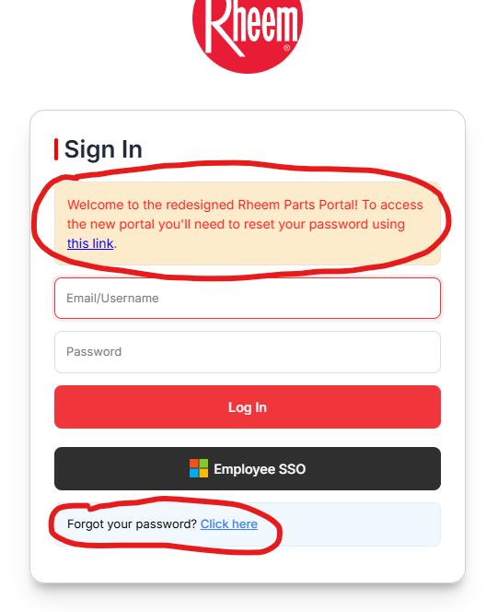

Step 2: Enter the email associated with the account you use to login to rheemparts.com and click “Submit”. This will send an email to your inbox with a link to reset your password.
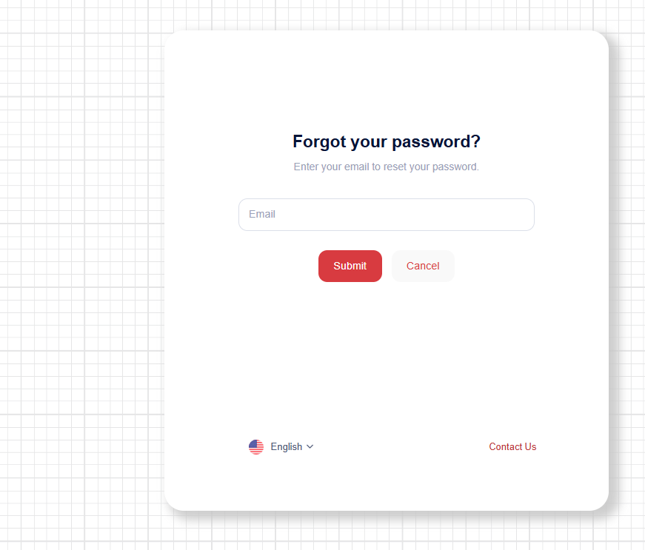

Step 3: Click the “Reset Password” button on the email you receive. This is only valid for one hour after the email is sent to your inbox.
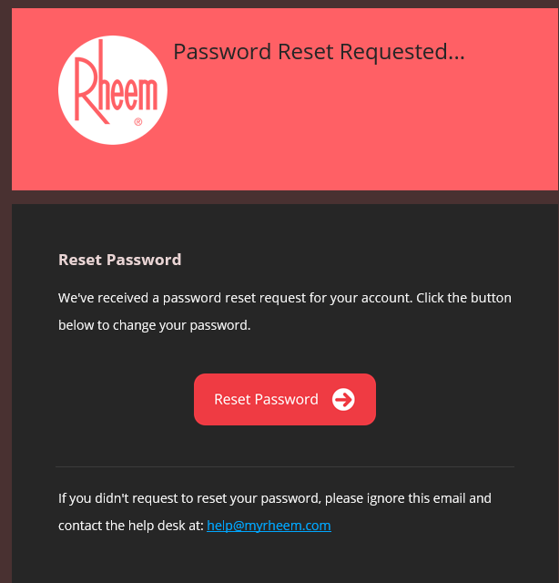

Step 4: This will bring you to the password reset page. Enter your email and new password, then confirm your new password and click “Submit”.
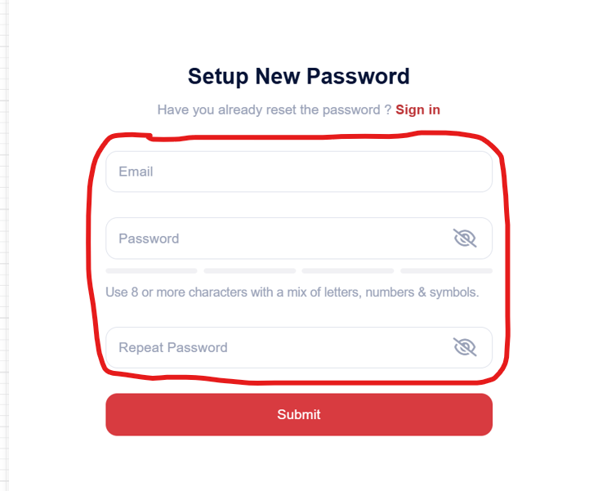

Step 5: at https://www.rheemparts.com/parts, type in your username and new password. Then click the “Login” button. This will log you in to rheemparts.com.
